**LAB REPORT NO 1**



**CSE-206L Electronic Circuits Lab**

Submitted by:  **Muhammad Ali**

Registration No:- **19PWCSE1801**

Class Section: A

“On my honor, as student of University of Engineering and Technology, I have neither given nor received unauthorized assistance on this academic work.”

Submitted to:

**Engr. Abdullah Hamid**

Data:(21,04,2021)

Department of Computer Systems Engineering

University of Engineering and Technology, Peshawar

**Experiment 1: OSCILLOSCOPE AND FUNCTION GENERATOR OPERATION**

**Objectives: -**

* To know about proteus software.
* To draw a simple circuit in proteus.
* To make schematic capture and PCB layout of a circuit.
* To check the function of DC voltmeter and ammeter with the circuit.

**Introduction to proteus: -**

The Proteus Design Suite is a proprietary software tool suite used primarily for electronic design automation. The software is used mainly by electronic design engineers and technicians to create schematics and electronic prints for manufacturing printed circuit boards.

Proteus is used to simulate, design and drawing of electronic circuits. It was invented by the Labcenter electronic. By using proteus you can make two-dimensional circuits designs as well. With the use of this engineering software, you can construct and simulate different electrical and electronic circuits on your personal [computers](https://www.theengineeringknowledge.com/full-form-of-computer/) or laptops. There are numerous benefits to simulate circuits on proteus before make them practically.

**DC voltmeter and ammeter: -**

Ammeters measure the current through components. To measure the current going through a component, the ammeter is connected in series with the components we want to investigate. Resistors in series experience the same current. Typically, ammeters have negligible resistance, so they do not affect the circuit.

Voltmeters measure the electric potential drop across components. The voltmeter is placed in parallel with the component of interest because components in parallel experience the same potential difference.

**Oscilloscope:-**

The oscilloscope is the most widely used general-purpose measuring instrument because it allows you see a graph of the voltage as a function of time in a circuit. Many circuits have specific timing requirements or phase relationships that can be measured with a two channel oscilloscope. One can measure almost anything with the two-dimensional graph drawn by an oscilloscope like the average value, rms value, frequency and period of a

sinusoidal or a non-sinusoidal signal. The screen is divided into centimeter divisions in vertical and horizontal directions.

**Function Generator: -**

Function Generator is a supply that typically provides a sinusoidal, square-wave and triangular waveform for a range of frequencies and amplitudes. Although the frequency of the function generator can be set by the dial position and appropriate multiplier, the oscilloscope can be used to precisely set the output frequency. The scope can also be used to set the amplitude of the function generator.

**Experimental steps: -**

1. First we search for different components like (resistor, LED, battery) and draw a circuit with wiring.
2. DC voltmeter is used across the resistor to measure voltage and dc ammeter to measure current in the circuit.
3. Running the schematic will shows the values by DC voltmeter and ammeter.
4. Then we construct the same circuit on PCB layout.
5. Add packages of required components then saved them. And draw the PCB board size with “board edge”.
6. Connect the component according to PCB views lines.

**Schematic circuit: -**

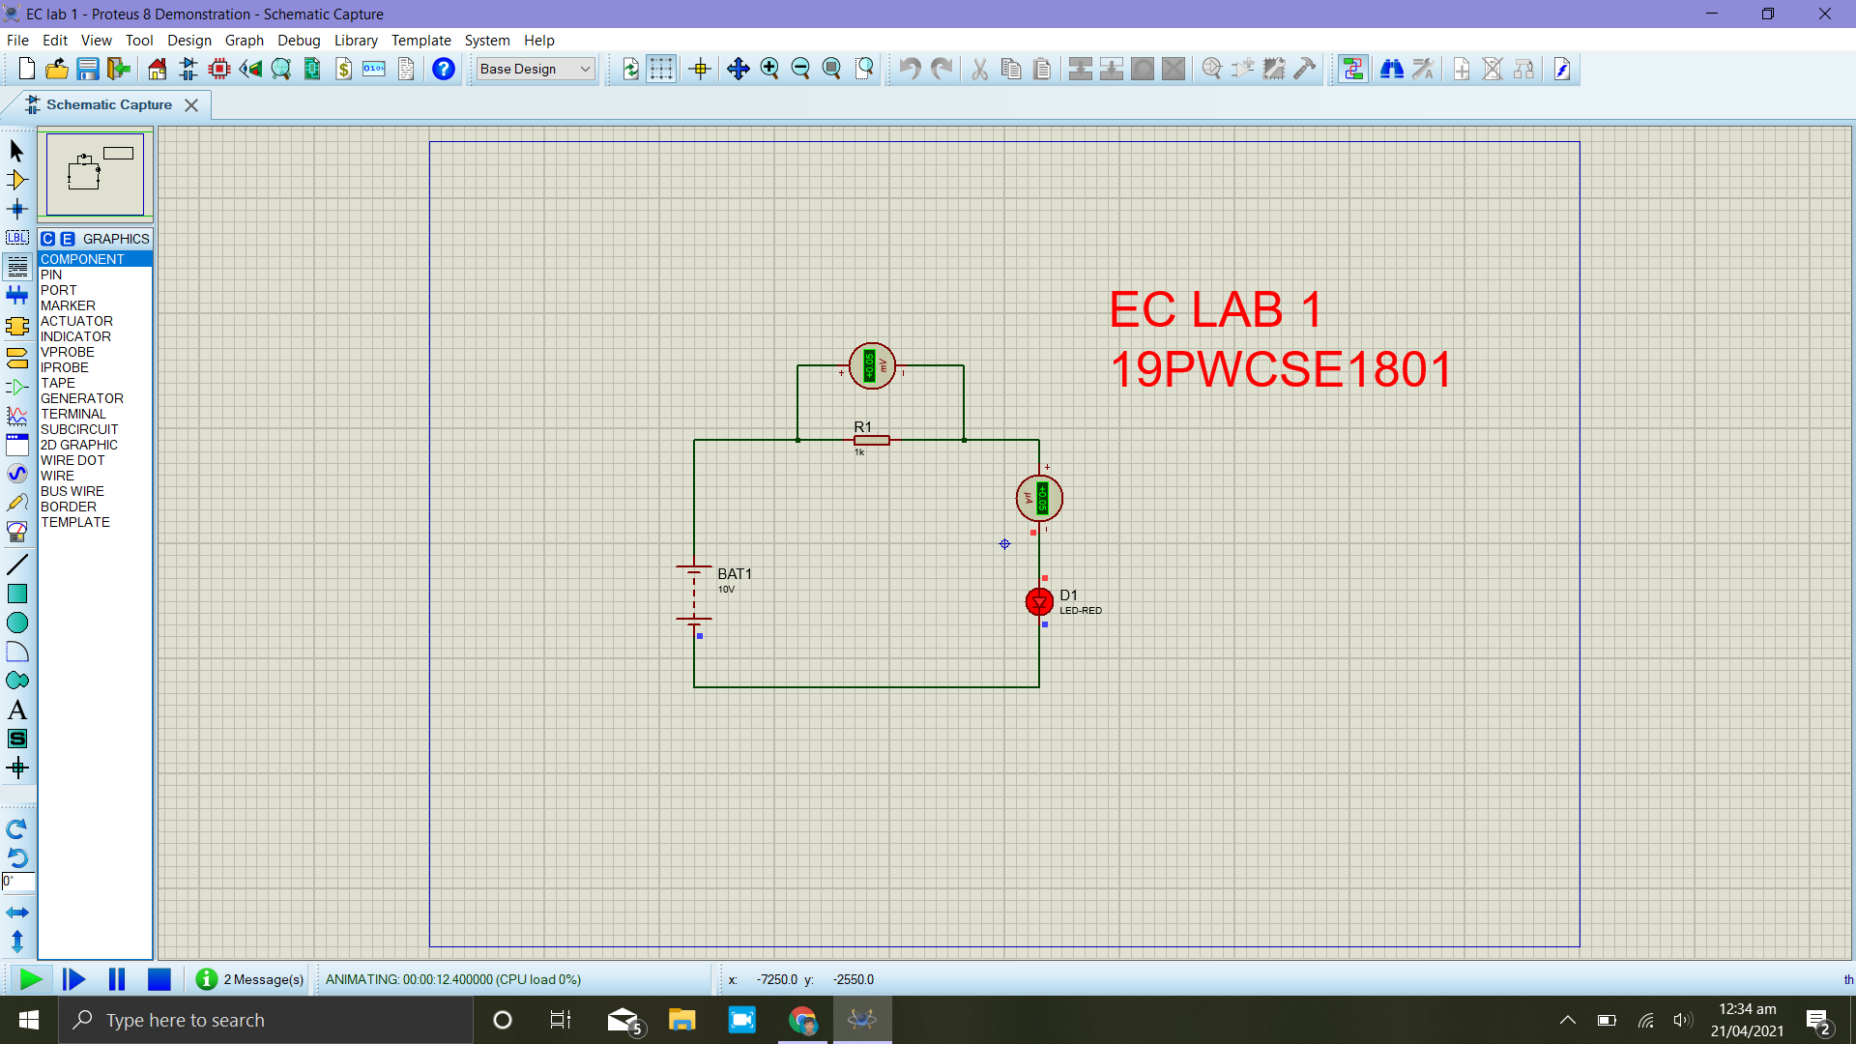

**PCB Circuit:-**

